**Ansible Assignment -1**

1. copy the file from /home/ubuntu/example6.txt /home/ubuntu/test8/example6.txt

3. Create one directory ( dir name: sample5 ) using file module

4. Create one file ( file name: test9.txt ) using file module

1. Shell module ( file ex: sample.txt )
   1. find the file which modified 4 months back & delete that

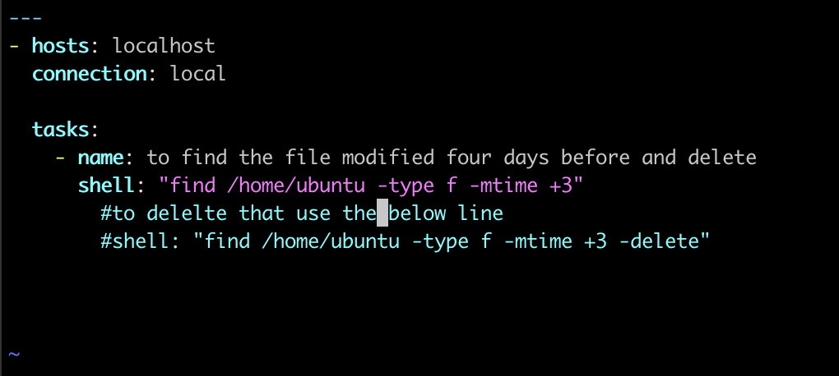

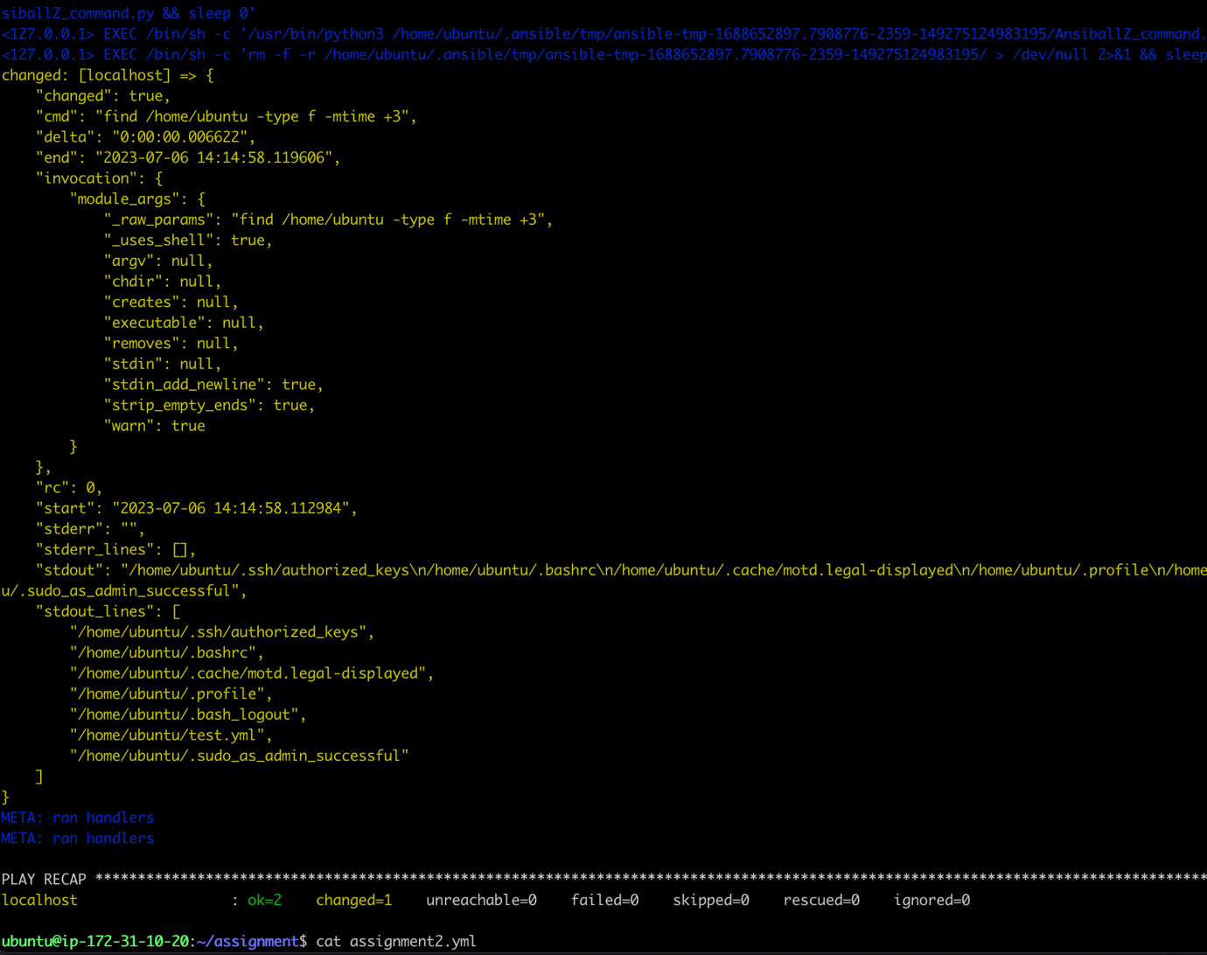

* 1. change the permission of a dir to 0755

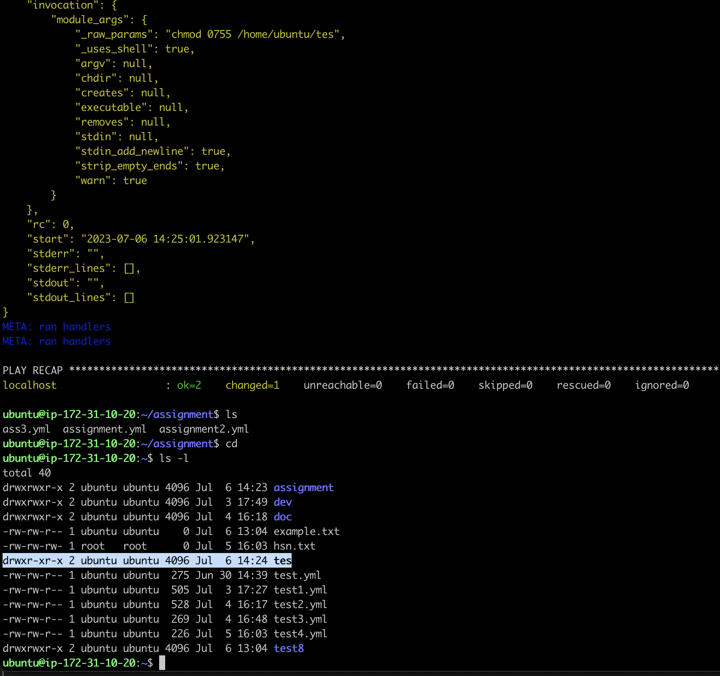

2.3 find out the mutiple patterns in a file ( for ex: cricket, football, Tennis )

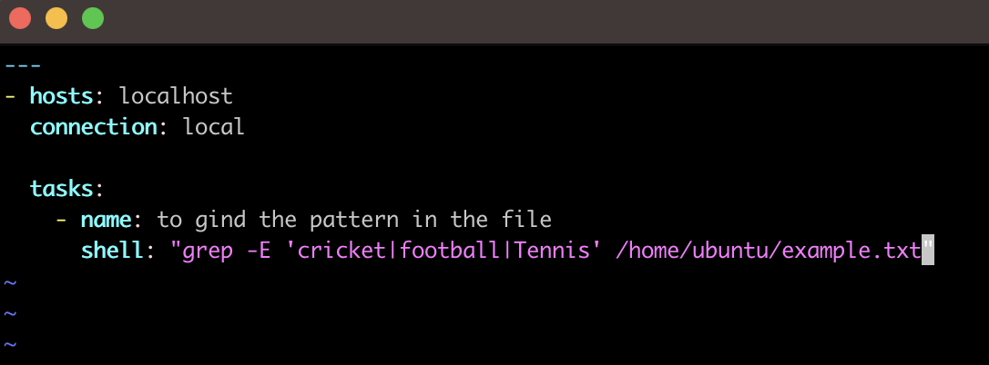

* 1. find out the characters in 5th line of a file

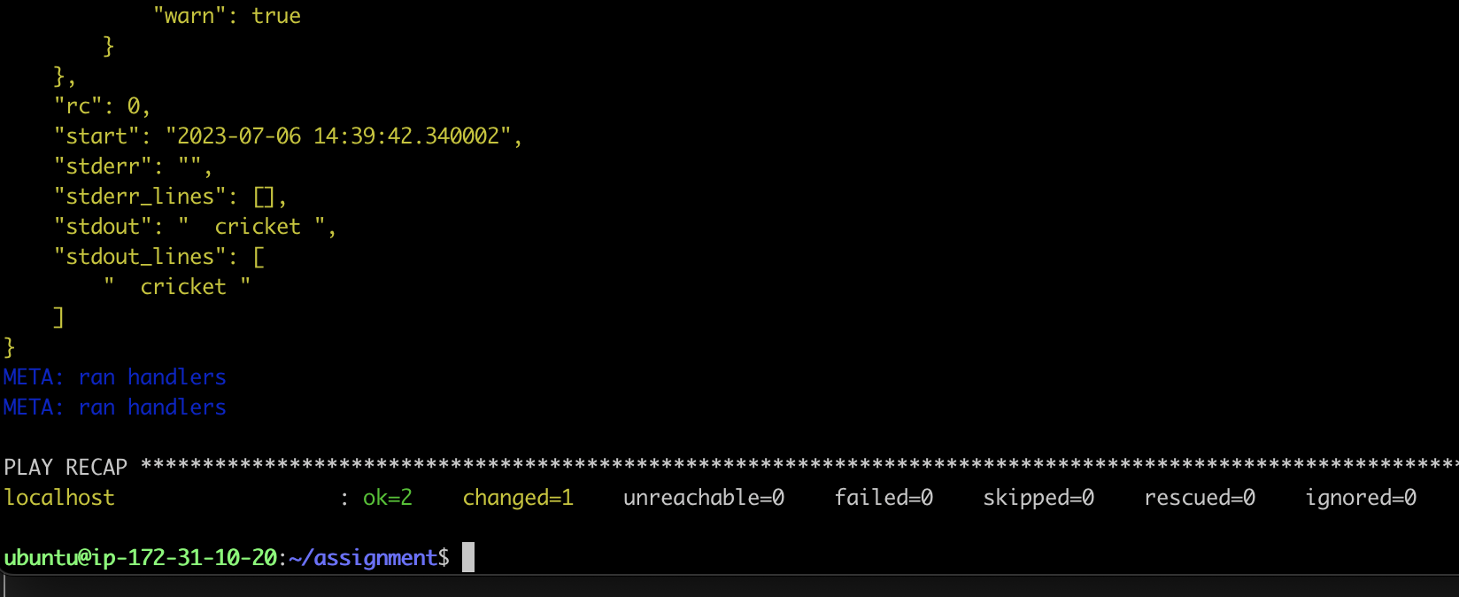

* 1. find out the disk usage of a file example.txt

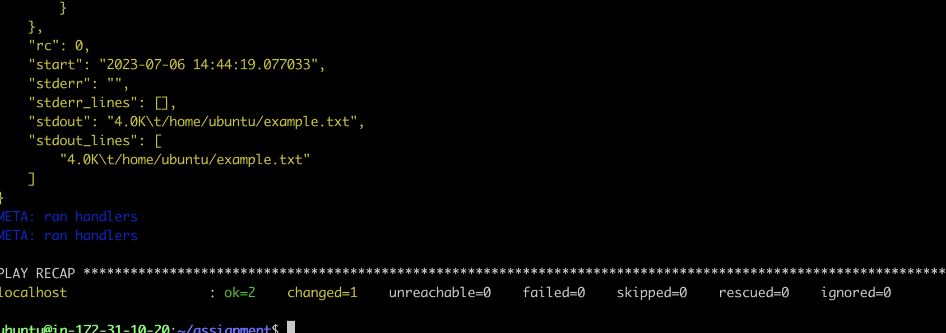

* 1. sort the file & find out only unique words in the sample.txt file

* 1. create one softlink for a file
  2. Display the content of a sample.txt file & redirect to log file

* 1. find out all non-empty files & append to test8.txt file

2.10) move the file to /home/ubuntu/test3.txt /home/ubuntu/test8/test3.txt

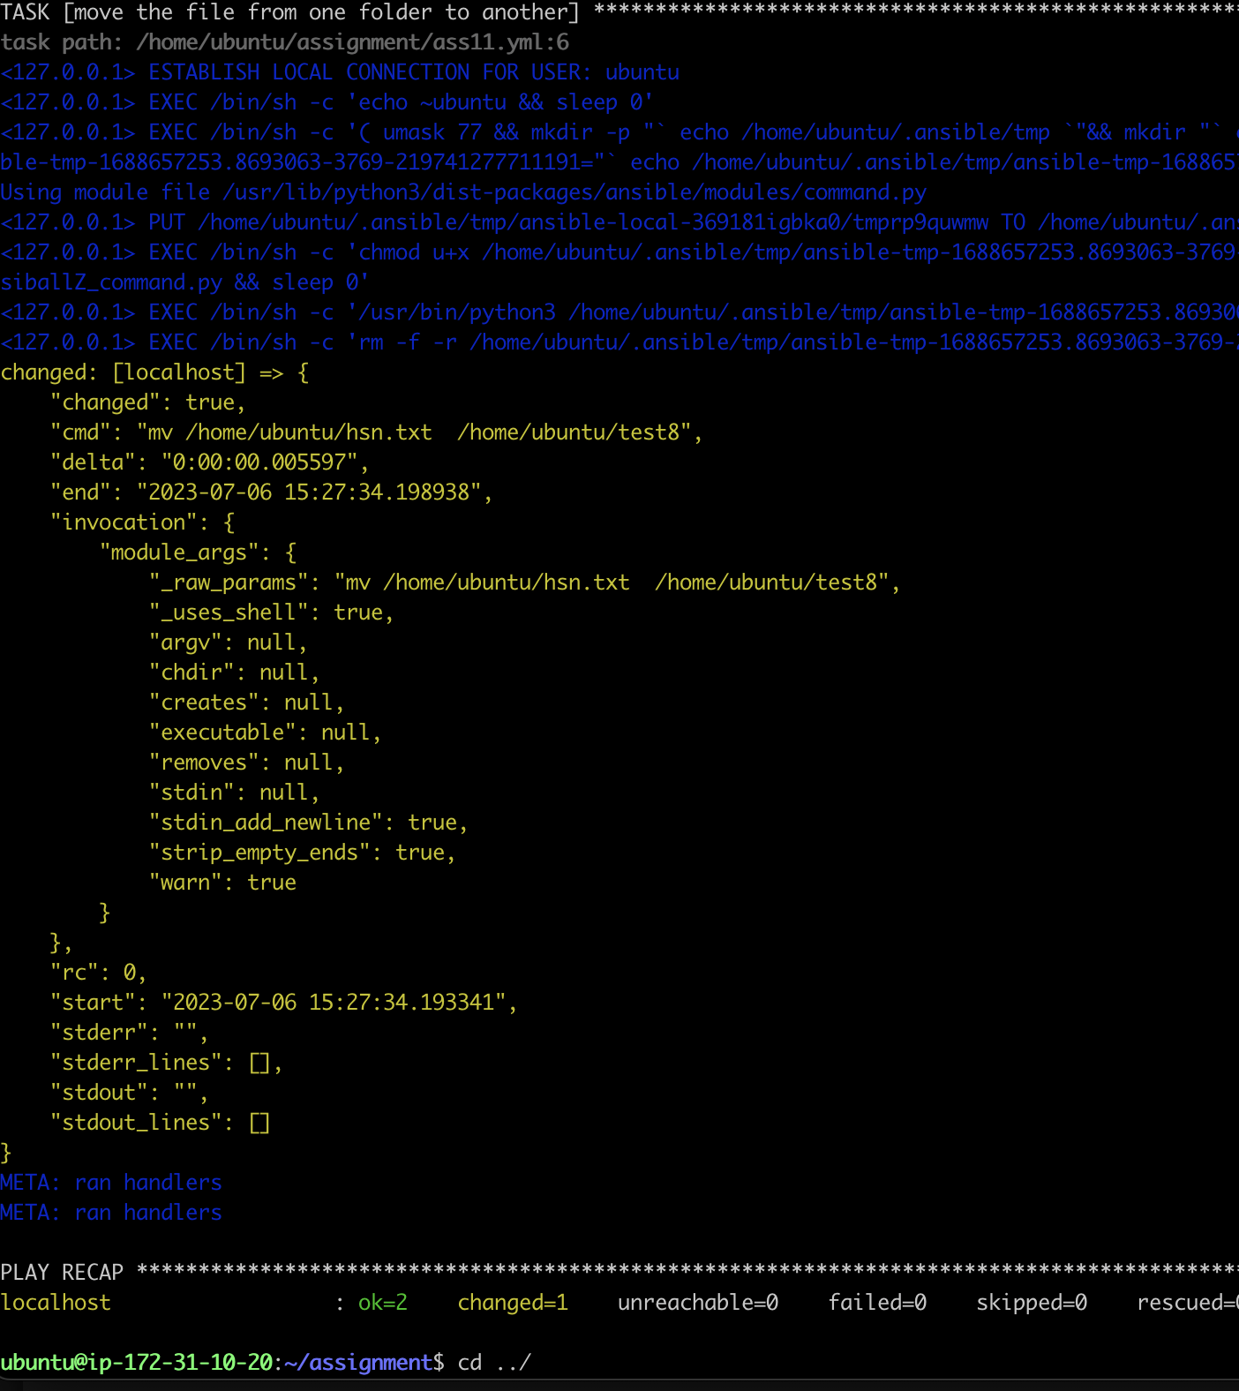

5) Find out the all txt files in path: /home/ubuntu/

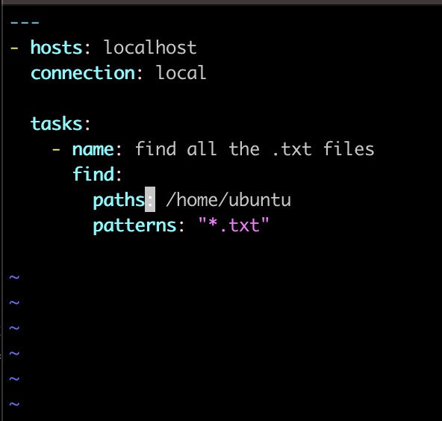

6) Display the content of a file in path: /home/ubuntu/test5/sample6.txt

use args , chdir argument & write playbook

7) Create one file ( file name: example3.txt ) using file module & add ignore_errors for that task

8) Check the xml files count & then register ( path: /home/ubuntu/dev)

condition 1: if xml count != 0 then copy the xml files from /home/ubuntu/dev/*.xml /home/ubuntu/doc)

condition 2: if xml count == 0 then create a new dir (path: /home/ubuntu/dir)

9) Check the txt files count & then register ( path: /home/ubuntu/dir3)

condition 1: if txt count != 0 then copy the txt files from /home/ubuntu/dir3/*.txt /home/ubuntu/dir6)

condition 2: if txt count == 0 then create a new file (path: /home/ubuntu/test7.zip)

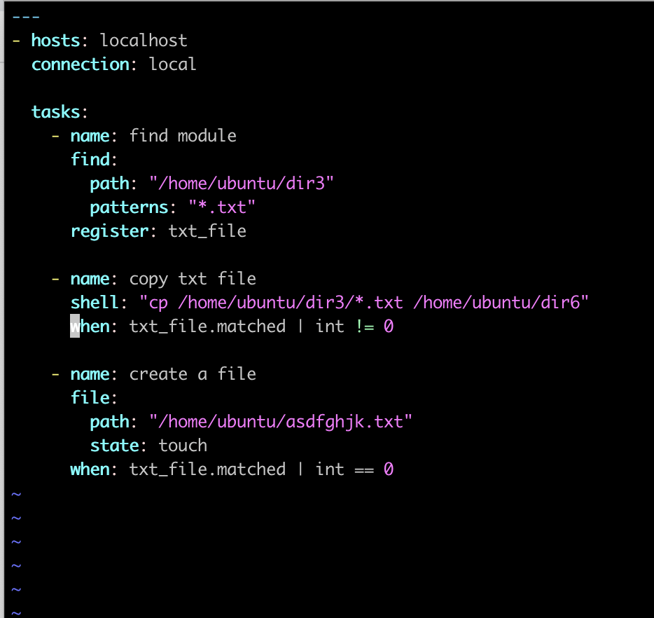

10) Find out the all zip files in path: /home/ubuntu/dir4

